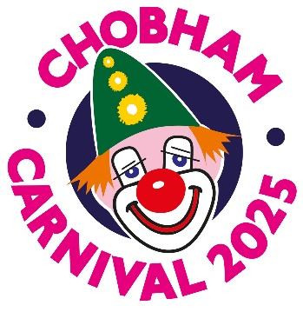

**2025 CARNIVAL BALL TICKET APPLICATION**

**Chobham Village Hall – Saturday May 3rd**

Name

Address

[Tel](Tel:………………………………………………………………………………………)ephone Number

Email

Please reserve me ………………tickets for the ball at £45 each.

My total payment is: £………. **Payment by online funds transfer is preferred**. Cheques are also acceptable and should be made out to Chobham Carnival Association.

I enclose a cheque (tick) ………

I am paying online (tick) ………….

Please add a reference: Ball & your Surname – Sort code 20.90 56, Account 90255092, Chobham Carnival Association

**On the day:**

• Dress code: “black tie”.

• Ticket price covers: Canapes, a two-course meal with coffee. There is a live band and a beer, wine and soft drinks bar.

* Paper tickets will not be issued but an acknowledgement will be sent by email.

• Doors open at 6pm, canapes are served from 6.30pm

• There will be a raffle and a silent auction of donated items, proceeds to the carnival’s good causes fund.

• We will endeavour to seat groups of friends together on the same table – based on the surname of the person who books.

**Send this form with payment BEFORE APRIL 17th (EMAIL PREFERRED) to:** tony.hunt139@gmail.com   
**or post to:**  
Chobham Carnival Ball Tickets, c/o Tony Hunt, Grove Farm, Scotts Grove Road, Chobham Surrey GU24 8DP

Enquiries to the above email or by phone to 07437 476238